Mortgage Project

# Title: Morgtage - 1003 Application Processing

# Document Participants and Approvals

Primary Author: Ali Muwwakkil

Contributors: Ali Muwwakkil

Reviewers: Anand Dasari

Ram Kotamaraja

# Approvals

**The following have reviewed and/or approved this document:**

|  |  |  |  |
| --- | --- | --- | --- |
| Approver | Group | Date Submitted | Date Approved |
| Ali Muwwakkil |  |  |  |
| Anand Dasari |  |  |  |
| Ram Kotamaraja |  |  |  |
|  |  |  |  |

# Revision History

This section records the change history of this document.

|  |  |  |  |
| --- | --- | --- | --- |
| **Name** | **Date** | **Reason For Changes** | **Version** |
| Ali Muwwakkil | 6-29-2012 | Original Draft | 1.0 |

Table of Contents

Title: Mortgage 1003 application processing 1

Document Participants and Approvals 1

Approvals 1

Revision History 1

Requirements 3

Mortgage 1003 application processing Overview 3

Adventure Works Sales Dashboard Report Navigation 3

Novedea Adventure Works Sales Dashboard filters 6

Filters …….6

Loans Dashboard To Date 8

Loans To Date 9

Loans To Date by Purpose of Loan 10

Loans To Date by Loan Amount 11

Loans To Date by Property Usage 12

Loans Dashboard to Date / Demographics 13

Loans To Date by Martial Status 14

Loans To Date by Age Group 15

Loans To Date by Race 16

Loans To Date by Sex 17

Loan Overview 18

MTD vs Prior 6 Month Avg 19

Last Mnt vs Prior 6 Mnt Avg 20

QTD vs Last Full Quarter 21

Avg Loan - % Monthly Income By Month 22

Loan Count by Month 23

Loan Count by Quarter 24

Loan Dashboard Details 25

# Requirements

## Morgtage - 1003 Application Processing

The Company is in need of a Dashboard to track activity based on WeekToDate – MonthToDate – YearToDate, Demographics and Loan Overview

The Dashboard will consist of 4 reports all tied to Loan Process. Metrics provided will enable the company to have site into many different aspects of the business.

## Morgtage - 1003 Application Processing Report Navigation

#### Snapshot of Desired Dashboard Results

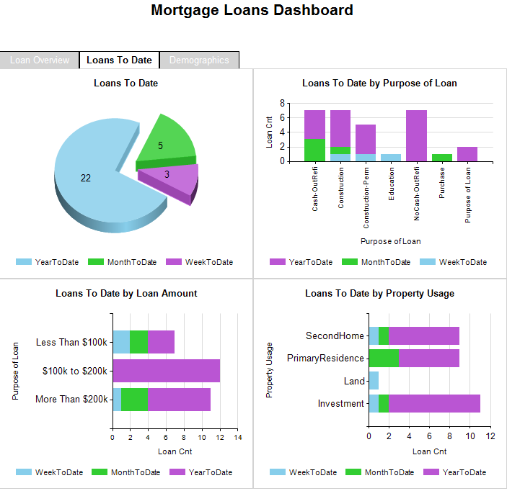

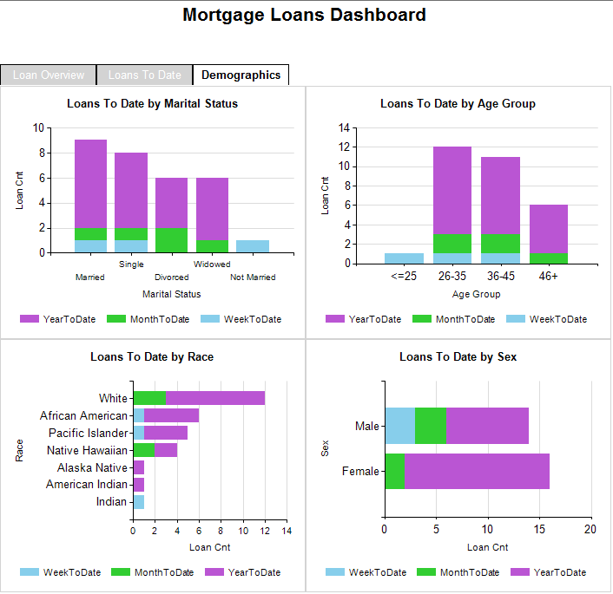

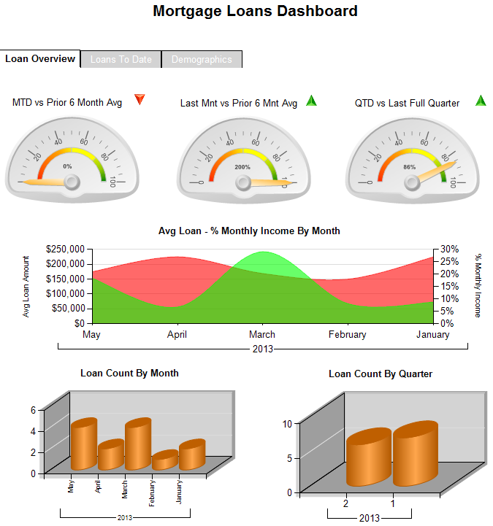

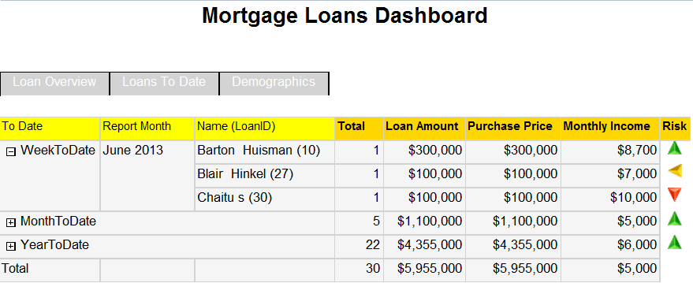

### Morgtage - 1003 Application Processing filters

#### Filters

1. **Report Date** – Every loan has a loan date. I want to see a list of all dates and I want the report to default to the most current loan date.
2. **Loan Amount** – Categorize the Loans into 3 groups
   1. Less Than $100k
   2. $100k to $200k
   3. More than $200k
3. **Loan Purpose**
4. **Property Usage**
5. **Demographics Group** – Age / Marital Status / Race / Sex
6. **Demographics Details** – This should display all demographic options. If I select a demographics Group, I would like this list to automatically filter by the attributes in on the groups I selected. For example if I select Marital Status for the Demographics Group filter, this filter should only show the different Marital Status’.
   1. Age – Categorize the Age into the following groups
      1. <= 25
      2. 26-35
      3. 36-45
      4. 46+
   2. Marital Status
   3. Race
   4. Sex

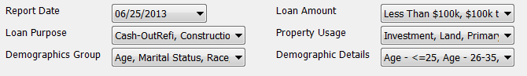

| **Filter** | **Display Method** | **Table** | **Example** | **Notes** |
| --- | --- | --- | --- | --- |
| Report Date | Single Value | Dim_Loan | 6/252013  6/24/2013  6/18/2013  6/15/2013 | Report Date should default to the most recent loan date. |
| Loan Amount | Multi-Select List | Fact_Financials | Less Than $100k  $100k to $200k  More Than $200k | Loan Amount should default to all Loan Amount Groups |
| Loan Purpose | Multi-Select List | Dim_Loan | * Cash-OutRefi * Construction * Purchase * Etc… | Loan Amount should default to all Loan Purposes |
| Property Usage | Multi-Select List | Dim_Property | * Investment * Land * Second Home * Etc… | Loan Amount should default to all Property Usages |
| Demographics Groups | Multi-Select List | Hard-Coded | * Marital Status * Age * Race * Sex | Loan Amount should default to the values in the Example section to the left |
| Demographics Details | Multi-Select List | Dim_Borrower | * Age – 26-35 * Age – 36-45 etc… * Marital Status – Divorced etc… * Race – Indian etc… * Sex – Male etc… |  |

***Functionality:***

When I select a tab, I want to be able to navigate to the associated report and also pass my same filters that were already selected. Active tables should be white with black font (bold). Inactive tabs should be LightGrey with white font.



### Loan Dashboard To Date



|  |  |  |
| --- | --- | --- |
| |  | | --- | | Loans To Date | | Indicates the Total Count of Loans grouped by the following ToDate’s. Legend at the bottom of the graph with an entry for all 3 Groups. | |
| |  |  | | --- | --- | | Name: | Loans To Date | | Type: | Pie Chart | | X Axis | N/A | | Y Axis | N/A | | Other: |  | | Tables: | Dim_Loan | | Drill-through Report: | LoanDashboardDetails | | Notes: | N/A | |

.

### 

### Loans To Date by Purpose of Loan

|  |  |  |
| --- | --- | --- |
| |  | | --- | | Loans To Date by Purpose of Loan | | Indicates Total number of Loans (ToDate) graphed by Purpose of Loan. Should also be broken down by WeekToDate / MonthToDate / YearToDate | |

|  |  |
| --- | --- |
| Name: | Loans To Date by Purpose of Loan |
| Type: | Column Chart |
| X Axis | Purpose of Loan |
| Y Axis | Total Loan Count |
| Other: | Count should be separated by WeekToDate / MonthToDate / YearToDate |
| Tables: | Dim_Loan |
| Drill-through Report: | LoanDashboardDetails |
| Notes: | N/A |

|  |  |  |  |
| --- | --- | --- | --- |
| Loans To Date by Loan Amount    |  | | --- | | Loans To Date by Loan Amount | | Indicates Total number of Loans (ToDate) graphed by Purpose of Loan. Should also be broken down by WeekToDate / MonthToDate / YearToDate | |  | |

|  |  |
| --- | --- |
| Name: | Loans To Date by Loan Amount |
| Type: | Bar |
| X Axis | Loan Count |
| Y Axis | Purpose of Loan |
| Other: | N/A |
| Tables: | Dim_Loan / Fact_Financial |
| Drill-through Report: | LoanDashboardDetails |
| Notes: | N/A |

|  |  |  |  |
| --- | --- | --- | --- |
| Loans To Date by Property Usage    |  | | --- | | Loans To Date by Property Usage | | Indicates Total number of Loans (ToDate) graphed by Property Usage. Should also be broken down by WeekToDate / MonthToDate / YearToDate | |  | |

|  |  |
| --- | --- |
| Name: | Loans To Date by Property Usage |
| Type: | Bar |
| X Axis | Loan Count |
| Y Axis | Property Usage |
| Other: | N/A |
| Tables: | Dim_Property / Dim_Loan |
| Drill-through Report: | LoanDashboardDetails |
| Notes: | N/A |

### Loan Dashboard To Date - Demographics



|  |  |  |  |
| --- | --- | --- | --- |
| Loans To Date by Marital Status    |  | | --- | | Loans To Date by Marital Status | | Indicates Total number of Loans (ToDate) graphed by Marital Status. Should also be broken down by WeekToDate / MonthToDate / YearToDate | |  | |

|  |  |
| --- | --- |
| Name: | Loans To Date by Marital Status |
| Type: | Column |
| X Axis | Marital Status |
| Y Axis | Loan Count |
| Other: | N/A |
| Tables: | Dim_Borrower / Dim_Loan |
| Drill-through Report: | LoanDashboardDetails |
| Notes: | N/A |

|  |  |  |  |
| --- | --- | --- | --- |
| Loans To Date by Age Group    |  | | --- | | Loans To Date by Age Group | | Indicates Total number of Loans (ToDate) graphed by Age Group. Should also be broken down by WeekToDate / MonthToDate / YearToDate. | |  | |

|  |  |
| --- | --- |
| Name: | Loans To Date by Property Usage |
| Type: | Column |
| X Axis | Age Group |
| Y Axis | Loan Count |
| Other: | N/A |
| Tables: | Dim_Borrower / Dim_Loan |
| Drill-through Report: | LoanDashboardDetails |
| Notes: | Must break Ages down into groups |

|  |  |  |  |
| --- | --- | --- | --- |
| Loans To Date by Race    |  | | --- | | Loans To Date by Race | | Indicates Total number of Loans (ToDate) graphed by Race. Should also be broken down by WeekToDate / MonthToDate / YearToDate | |  | |

|  |  |
| --- | --- |
| Name: | Loans To Date by Age Group |
| Type: | Bar |
| X Axis | Loan Count |
| Y Axis | Race |
| Other: | N/A |
| Tables: | Dim_Borrower / Dim_Loan |
| Drill-through Report: | LoanDashboardDetails |
| Notes: | N/A |

|  |  |  |  |
| --- | --- | --- | --- |
| Loans To Date by Sex    |  | | --- | | Loans To Date by Sex | | Indicates Total number of Loans (ToDate) graphed by Sex. Should also be broken down by WeekToDate / MonthToDate / YearToDate. | |  | |

|  |  |
| --- | --- |
| Name: | Loans To Date by Property Usage |
| Type: | Bar |
| X Axis | Loan Count |
| Y Axis | Sex |
| Other: | N/A |
| Tables: | Dim_Borrower / Dim_Loan |
| Drill-through Report: | LoanDashboardDetails |
| Notes: | N/A |

### Loan Dashboard - Overview



|  |  |  |  |
| --- | --- | --- | --- |
| MTD vs Prior 6 Month Avg    |  | | --- | | Loans To Date by Property Usage  Calculation: MTD Loan Count / Prior 6 Months not including current month  Scale: 0 to 100 %  Range 1 – 0 to 50%  Range 2 – 51 to 75%  Range 3 – 76+% | |  | |  | |

|  |  |
| --- | --- |
| Name: | MTD vs Prior 6 Month Avg |
| Type: | Bar |
| X Axis | Loan Count |
| Y Axis | Property Usage |
| Other: | N/A |
| Tables: | Fact_Financial / Dim_Loan |
| Drill-through Report: | N/A |
| Notes: | N/A |

|  |  |  |  |
| --- | --- | --- | --- |
| Last Mnt vs Prior 6 Mnt Avg    |  | | --- | | Last Mnt vs Prior 6 Mnt Avg | | Calculation: Last Months Loan Count / Prior 6 Months not including last month  Scale: 0 to 100 %  Range 1 – 0 to 50%  Range 2 – 51 to 75%  Range 3 – 76+% | |  | |

|  |  |
| --- | --- |
| Name: | Loans To Date by Property Usage |
| Type: | Bar |
| X Axis | Loan Count |
| Y Axis | Property Usage |
| Other: | N/A |
| Tables: | Fact_Financial / Dim_Loan |
| Drill-through Report: | N/A |
| Notes: | N/A |

|  |  |  |  |
| --- | --- | --- | --- |
| QTD vs Last Full Quarter    |  | | --- | | QTD vs Last Full Quarter | | Calculation: QTD Loan Count / Last Full Quarter not including Current Quarter  Scale: 0 to 100 %  Range 1 – 0 to 50%  Range 2 – 51 to 75%  Range 3 – 76+% | |  | |

|  |  |
| --- | --- |
| Name: | Loans To Date by Property Usage |
| Type: | Bar |
| X Axis | Loan Count |
| Y Axis | Property Usage |
| Other: | N/A |
| Tables: | Fact_Financial / Dim_Loan |
| Drill-through Report: | N/A |
| Notes: | N/A |

|  |  |  |  |
| --- | --- | --- | --- |
| Avg Loan - % Monthly Income By Month    |  | | --- | | Avg Loan - % Monthly Income By Month | | Indicates Total number of Loans (ToDate) graphed by Property Usage. Should also be broken down by WeekToDate / MonthToDate / YearToDate | |  | |

|  |  |
| --- | --- |
| Name: | Avg Loan - % Monthly Income By Month |
| Type: | Bar |
| X Axis | Month / Year of Loan Date |
| Y Axis | Loan Amount |
| Other: | Secondary axis is % of Avg Loan Amont / Monthly Income |
| Tables: | Fact_Financial / Dim_Loan |
| Drill-through Report: | N/A |
| Notes: | N/A |

|  |  |  |  |
| --- | --- | --- | --- |
| Loan Count By Month    |  | | --- | | Loans Count By Month | | Indicates Total number of Loans by Month by Month / Year of Loan Date. | |  | |

|  |  |
| --- | --- |
| Name: | Loan Count By Month |
| Type: | Bar |
| X Axis | Month / Year of Loan Date |
| Y Axis | Loan Count |
| Other: | N/A |
| Tables: | Dim_Loan |
| Drill-through Report: | N/A |
| Notes: | N/A |

|  |  |  |  |
| --- | --- | --- | --- |
| Loan Count By Quarter    |  | | --- | | Loan Count By Quarter | | Indicates Total number of Loans by Month by Month / Year of Loan Date. | |  | |

|  |  |
| --- | --- |
| Name: | Loan Count By Quarter |
| Type: | Column |
| X Axis | Quarter / Year of Loan Date |
| Y Axis | Loan Count |
| Other: | N/A |
| Tables: | Dim_Loan |
| Drill-through Report: | N/A |
| Notes: | N/A |



Risk – Calculation based on Monthly Income / Loan Amount.

1. Green Arrow – Sum of Monthly Income / Sum of Loan Amount > 10%
2. Yellow Arrow – Sum of Monthly Income / Sum of Loan Amount between 7 and < 10%
3. Red Arrow - Sum of Monthly Income / Sum of Loan Amount < 7%

When I click on any of the graphs for the *ToDate Report* and the *Demographics Report*, I would like it to drill through to a matrix report so I can see the details of the group I selected. All previously selected filters should also be filtered in the Matrix Report. For example if I click on the Divorced Group in the Marital Status graph in the Demographics report, the matrix report should show all loans from Divorcees along with any other parameter that was included at the time I clicked on the Divorced Group. The matrix will resemble the following picture: